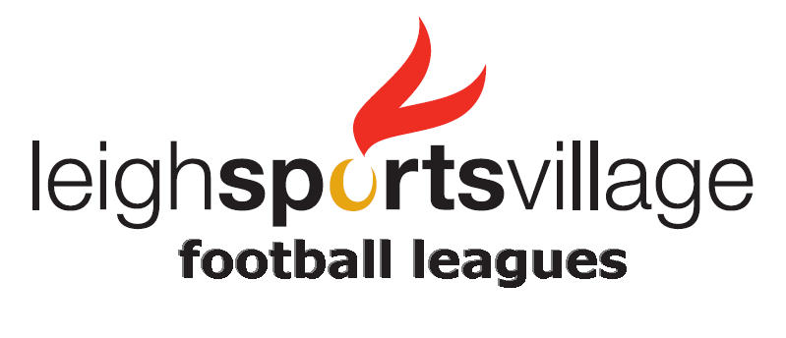

Leigh Sports Village Code of Conduct

Football League Players

We all have a responsibility to promote high standards of behaviour in the game.

Players tell us they want a referee for every match, yet thousands of match officials drop out because of the abuse and intimidation they receive on and off the pitch. Respect your referee today and you may just get one for every match this season.

As a player, you have a big part to play and this is why we are asking every player to follow a code of conduct. Please follow this code at all times.

On and off the field, I will:
- Play fairly - I won’t cheat, complain or waste time
- Respect my team-mates and the opposition team
- Adhere to the laws of the game
- Display and promote high standards of behaviour
- Promote Fair Play
- Always respect the match official’s decisions
- Never engage in public criticism of the match officials
- Never engage in bullying, intimidation or harassment

I understand that if I do not follow the code of conduct any/all of the following actions may be taken by Leigh Sports Village, Lancashire FA or The FA:
- Be required to apologise to team-mates, the opposition team or the referee
- Be required to serve a suspension
- Be fined

In Addition:
- The FA/County FA could impose a fine and/or suspension on the team

www.leighsportsvillage.co.uk full-time.thefa.com

